Server Migration

🌟 Definition
# Source: AI Source: Provided by: [Data Path: Persons Table -> ID Column: 1, Name_En Column: Motasem Essam] -> From: [ChatGPT] on [6/7/2026]
Server Migration is the process of moving applications, websites, databases, files, services, or entire systems from one server to another.
The goal is to transfer workloads while keeping services available and data intact.

🎯 Purpose
# Source: AI Source: Provided by: [Data Path: Persons Table -> ID Column: 1, Name_En Column: Motasem Essam] -> From: [ChatGPT] on [6/7/2026]
Server migration is performed to:
- Upgrade hardware
- Improve performance
- Increase storage capacity
- Improve security
- Move to the cloud
- Reduce hosting costs
- Replace aging servers

🧠 Simple Definition
# Source: AI Source: Provided by: [Data Path: Persons Table -> ID Column: 1, Name_En Column: Motasem Essam] -> From: [ChatGPT] on [6/7/2026]
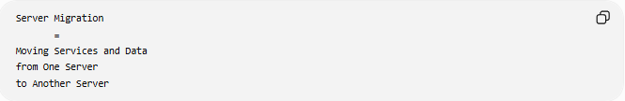
Server Migration
=
Moving Services and Data
from One Server
to Another Server

📚 What Can Be Migrated?
# Source: AI Source: Provided by: [Data Path: Persons Table -> ID Column: 1, Name_En Column: Motasem Essam] -> From: [ChatGPT] on [6/7/2026]
A server may host:
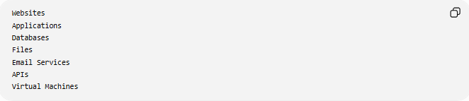
Websites
Applications
Databases
Files
Email Services
APIs
Virtual Machines
Any of these can be moved during a server migration.

🔍 Common Types of Server Migration

1️⃣ Physical-to-Physical Migration
# Source: AI Source: Provided by: [Data Path: Persons Table -> ID Column: 1, Name_En Column: Motasem Essam] -> From: [ChatGPT] on [6/7/2026]
Move from one physical server to another.
Example
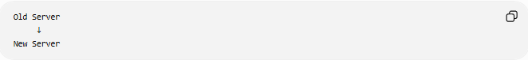
Old Server
↓
New Server
Used when upgrading hardware.

2️⃣ Physical-to-Virtual (P2V) Migration
# Source: AI Source: Provided by: [Data Path: Persons Table -> ID Column: 1, Name_En Column: Motasem Essam] -> From: [ChatGPT] on [6/7/2026]
Move from a physical server to a virtual machine.
Example
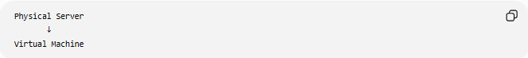
Physical Server
↓
Virtual Machine
Benefits:
- Better resource utilization
- Easier backups
- Easier management

3️⃣ Physical-to-Cloud Migration
# Source: AI Source: Provided by: [Data Path: Persons Table -> ID Column: 1, Name_En Column: Motasem Essam] -> From: [ChatGPT] on [6/7/2026]
Move workloads to the cloud.
Example
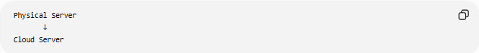
Physical Server
↓
Cloud Server
Common cloud providers:
- Amazon Web Services
- Microsoft
- Google

4️⃣ Server-to-Server Migration
# Source: AI Source: Provided by: [Data Path: Persons Table -> ID Column: 1, Name_En Column: Motasem Essam] -> From: [ChatGPT] on [6/7/2026]
Move services between servers.
Example
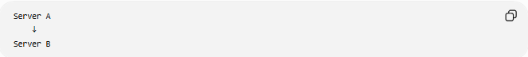
Server A
↓
Server B
Common for hosting upgrades.

5️⃣ On-Premises to Cloud Migration
# Source: AI Source: Provided by: [Data Path: Persons Table -> ID Column: 1, Name_En Column: Motasem Essam] -> From: [ChatGPT] on [6/7/2026]
Move systems from a company data center to the cloud.
Before
Company Data Center
After
Cloud Infrastructure

🛠️ Real-World Example
# Source: AI Source: Provided by: [Data Path: Persons Table -> ID Column: 1, Name_En Column: Motasem Essam] -> From: [ChatGPT] on [6/7/2026]
Before Migration
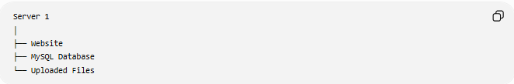
Server 1
│
├── Website
├── MySQL Database
└── Uploaded Files

Migration
Copy:
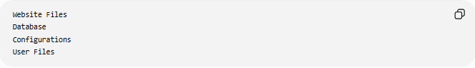
Website Files
Database
Configurations
User Files

After Migration
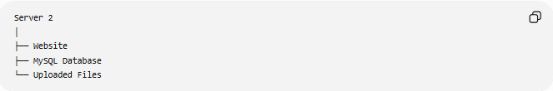
Server 2
│
├── Website
├── MySQL Database
└── Uploaded Files
Users continue using the website from the new server.

🌐 Website Migration Example
# Source: AI Source: Provided by: [Data Path: Persons Table -> ID Column: 1, Name_En Column: Motasem Essam] -> From: [ChatGPT] on [6/7/2026]
A company moves its website from one hosting provider to another.
Before
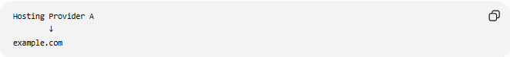
Hosting Provider A
↓
example.com

After
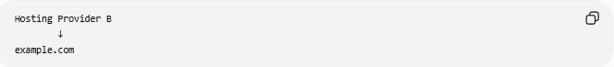
Hosting Provider B
↓
example.com
Migration includes:
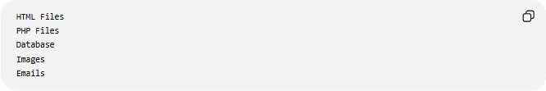
HTML Files
PHP Files
Database
Images
Emails

🗄️ Database Server Migration Example
# Source: AI Source: Provided by: [Data Path: Persons Table -> ID Column: 1, Name_En Column: Motasem Essam] -> From: [ChatGPT] on [6/7/2026]
Before
Old MySQL Server

After
New MySQL Server
Steps:
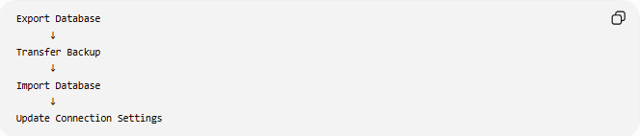
Export Database
↓
Transfer Backup
↓
Import Database
↓
Update Connection Settings

🔄 Server Migration Lifecycle
# Source: AI Source: Provided by: [Data Path: Persons Table -> ID Column: 1, Name_En Column: Motasem Essam] -> From: [ChatGPT] on [6/7/2026]
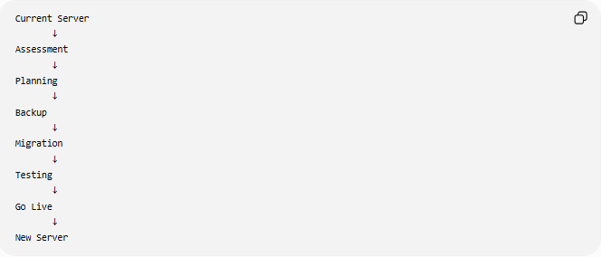
Current Server
↓
Assessment
↓
Planning
↓
Backup
↓
Migration
↓
Testing
↓
Go Live
↓
New Server

📦 Migration Strategies

# Source: AI Source: Provided by: [Data Path: Persons Table -> ID Column: 1, Name_En Column: Motasem Essam] -> From: [ChatGPT] on [6/7/2026]
Rehost (Lift and Shift)
Move everything without changes.
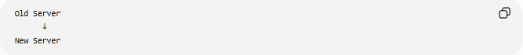
Old Server
↓
New Server
Fastest method.

Replatform
Move and make minor improvements.
Example:
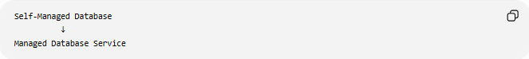
Self-Managed Database
↓
Managed Database Service

Rebuild
Create a new server environment from scratch.
Example:
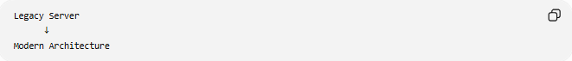
Legacy Server
↓
Modern Architecture

⚠️ Challenges of Server Migration
# Source: AI Source: Provided by: [Data Path: Persons Table -> ID Column: 1, Name_En Column: Motasem Essam] -> From: [ChatGPT] on [6/7/2026]
Possible issues:
- Downtime
- Data loss
- Configuration errors
- Network problems
- Security issues
- DNS propagation delays

✅ Best Practices
# Source: AI Source: Provided by: [Data Path: Persons Table -> ID Column: 1, Name_En Column: Motasem Essam] -> From: [ChatGPT] on [6/7/2026]
Backup Before Migration
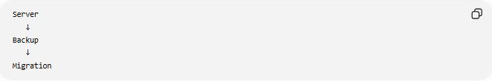
Server
↓
Backup
↓
Migration

Test in Staging
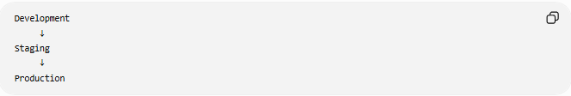
Development
↓
Staging
↓
Production

Verify Data Integrity
Check:
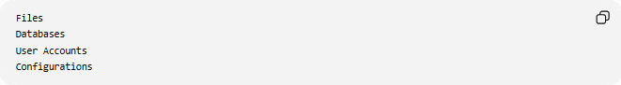
Files
Databases
User Accounts
Configurations

Plan Rollback
Always prepare:
Migration Plan
Rollback Plan

📊 Server Migration vs Application Migration
# Source: AI Source: Provided by: [Data Path: Persons Table -> ID Column: 1, Name_En Column: Motasem Essam] -> From: [ChatGPT] on [6/7/2026]
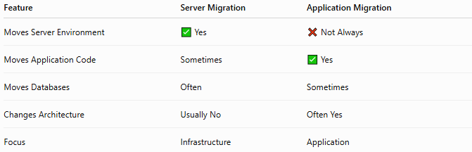
Feature | Server Migration | Application Migration
Moves Server Environment | ✅ Yes | ❌ Not Always
Moves Application Code | Sometimes | ✅ Yes
Moves Databases | Often | Sometimes
Changes Architecture | Usually No | Often Yes
Focus | Infrastructure | Application

🛠️ Common Tools Used
# Source: AI Source: Provided by: [Data Path: Persons Table -> ID Column: 1, Name_En Column: Motasem Essam] -> From: [ChatGPT] on [6/7/2026]
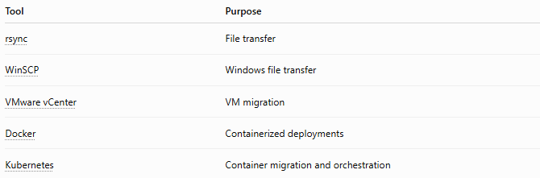
Tool | Purpose
rsync | File transfer
WinSCP | Windows file transfer
VMware vCenter | VM migration
Docker | Containerized deployments
Kubernetes | Container migration and orchestration

🧠 Simple Analogy
# Source: AI Source: Provided by: [Data Path: Persons Table -> ID Column: 1, Name_En Column: Motasem Essam] -> From: [ChatGPT] on [6/7/2026]
Imagine a restaurant moving to a new building.
Old Location
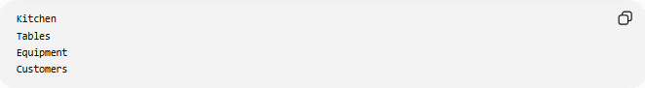
Kitchen
Tables
Equipment
Customers

Move
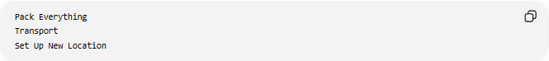
Pack Everything
Transport
Set Up New Location

New Location
Same Restaurant
Better Building
The business remains the same, but it operates from a new location.
Server migration works the same way: the services stay the same, but they run on a different server.

🧭 Summary
# Source: AI Source: Provided by: [Data Path: Persons Table -> ID Column: 1, Name_En Column: Motasem Essam] -> From: [ChatGPT] on [6/7/2026]
Server Migration is the process of moving websites, applications, databases, files, and services from one server environment to another. Common types include physical-to`-physical, physical-to-virtual, physical-to-cloud, server-to-server, and operating system migrations. The primary goals are improved performance, scalability, security, reliability, and modernization while minimizing downtime and preserving data.

